## Packaging and Deploying SPFX Solutions

**Lab Time**: 60 minutes

**Lab Folder**: C:\Student\Modules\06_PackagingAndDeployment\Lab

**Lab Overview**: Learning how to publish and install SharePoint Framework solutions correctly is a core skill that every SharePoint developer should know. In this lab you will create an app catalog and then you will learn how to publish and install SPFx solutions.

### Exercise 1: Create an App Catalog Site Collection

In this exercise you will create an app catalog to support app deployment and installation.

1. Navigate to the page in the SharePoint admin center which allows you to create the App catalog.
   1. Using the browser, navigate to the following URL in the SharePoint admin center

https://[TENANT_NAME]-admin.sharepoint.com/_layouts/15/online/ManageAppCatalog.aspx

* 1. Select the option to **Create a new app catalog site** (*it should be the default selection*).
  2. Click the **OK** button to continue.

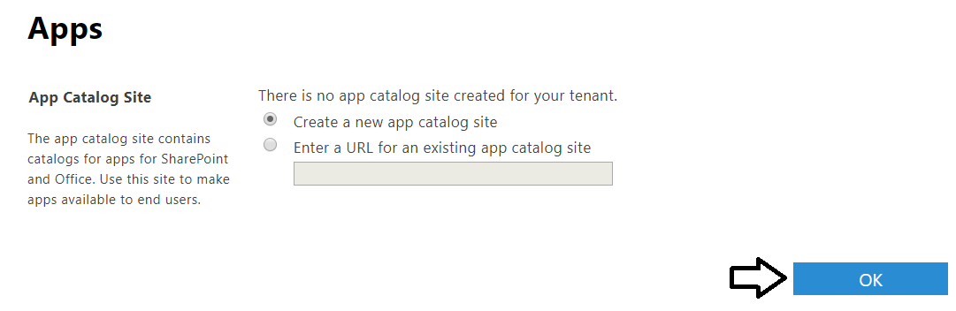

1. On the **Create App Catalog Site Collection** page…
   1. Enter a Title of **App Catalog Site**.
   2. Enter a **Web Site Address** of **https://[YOUR_TENANT_NAME].sharepoint.com/sites/AppCatalogSite**.
   3. Fill in the rest of the page using data shown in the following screenshot and click **OK** to create the App Catalog site collection.

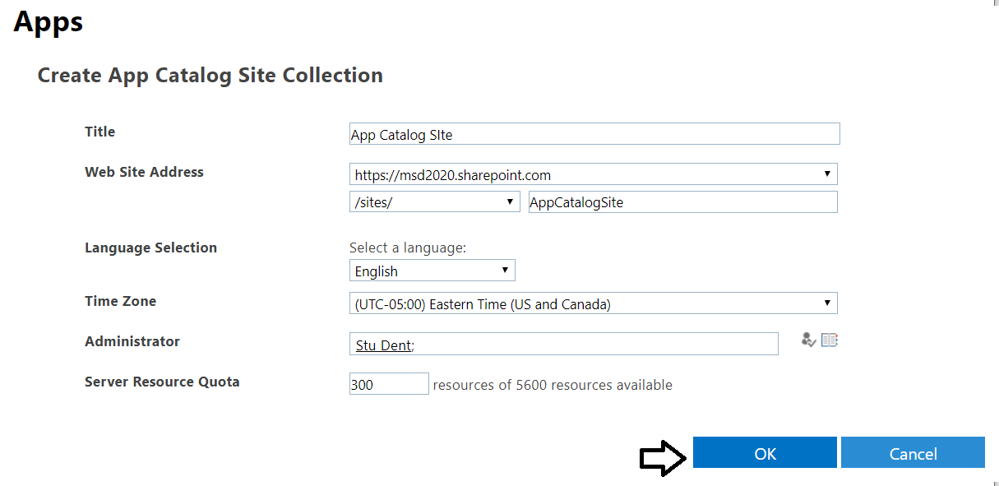

After clicking OK, you will be redirected back to the legacy tenant admin app page named **TenantAdminApps.aspx**. The SharePoint admin center doesn't really give any kind of notification to indicate it has begun to provision a new site collection of the App Catalog. Also the legacy page doesn't provide any navigation elements so you need to enter URL into the browser address bar to return back to the pat of the SharePoint admin center with the modern UI experienced.

* 1. Navigate back to the home page of the SharePoint admin center site at **https://[TENANT_NAME]-admin.sharepoint.com**.

1. Inspect the app catalog site
   1. You should be able to see **App Catalog Site** in the **Active sites** list.

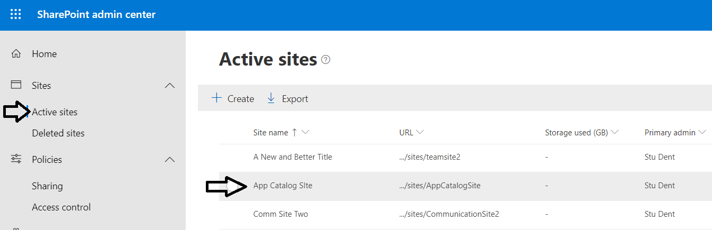

* 1. Select the **App Catalog Site** and then click its **URL** link in the **Properties** pane to navigate to the site

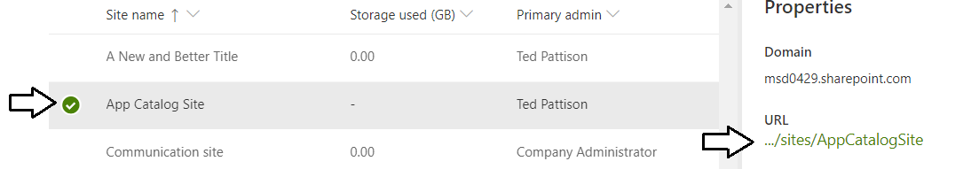

* 1. Once the new site collection has been fully created, navigate to it to see the App Catalog site.

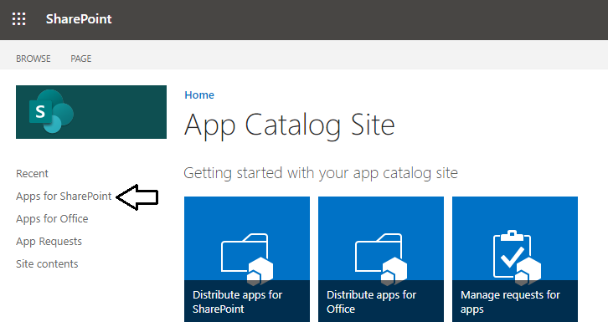

* 1. You should now see the default view of the document library named **Apps for SharePoint**. This is the library where you will upload your solution packages to publish them.

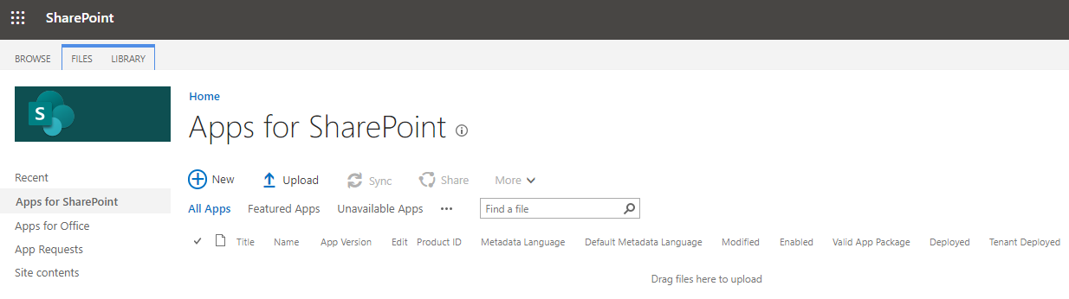

Now you are done configuring the your SharePoint Online tenant for publishing and deploying SharePoint Framework. Now, you will work to publish and install several different SharePoint Framework solution packages so you can get first-hand experience deploying SharePoint solutions in an Office 365 tenant.

1. Enable the Office 365 CDN for your tenant.
   1. From the Windows Start menu, open **SharePoint Online Management Shell**.

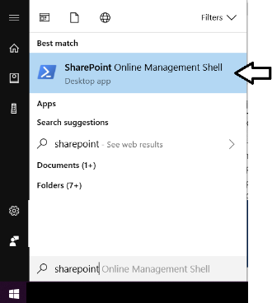

* 1. You should now see a new console window for the SharePoint Online Management Shell.

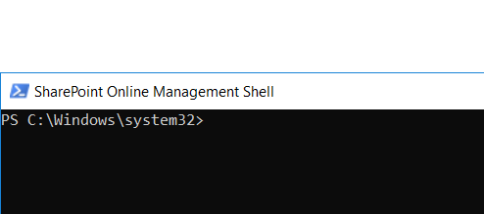

* 1. Run the following command to connect to your SharePoint Online tenant. Be sure to replace **[your tenant]** with the value you provided when creating your Office 365 tenant (this will be the same value that is preceding **onmicrosoft.com** in your login).

Connect-SPOService -Url https://[your tenant]-admin.sharepoint.com

When the **Connect-SPOService** cmdlet begins to execute, you will be prompted to sign in.

* 1. Enter the credentials of your primary Office 365 user account and click **Sign In**.

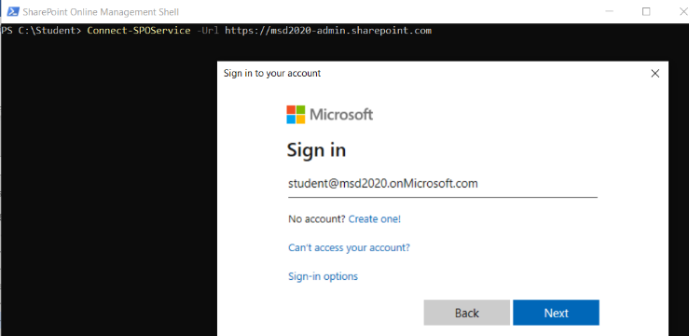

* 1. Once the call to **Connect-SPOService** returns, you can now begin to call the other SPO cmdlets.



* 1. Type and execute the following PowerShell command.

Set-SPOTenantCdnEnabled -CdnType Public

* 1. Confirm the action by typing **Y** and pressing **ENTER**.

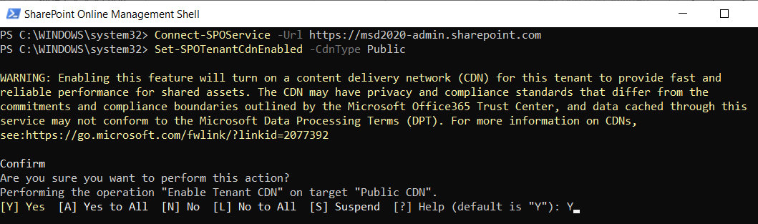

* 1. When you enable the Office 365 CDN, you'll see a warning indicating that files will be available through anonymous access.

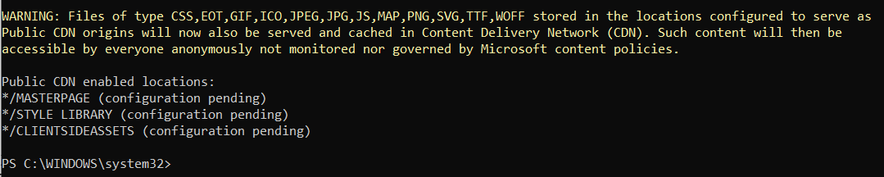

You have now enabled the Office 365 CDN for web part deployment.

### Exercise 2: Build and Deploy a Solution Package with a Webpart

In this exercise you will go through the steps to build solution packages for two SharePoint Framework projects for distribution.

1. Open the SharePoint Framework project named **CustomerSearch**.
   1. Using Windows Explorer, navigate to the lab folder for this module at the following path.

C:\Student\Modules\06_PackagingAndDeployment\Lab

* 1. You should see two folders with SharePoint Framework projects named **CustomerSearch** and **GlobalNavigation**.

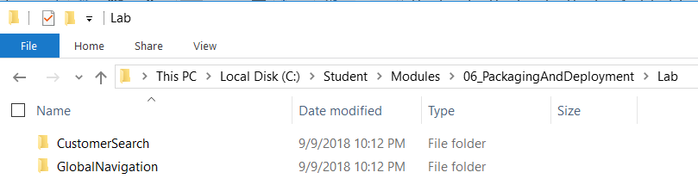

* 1. Open the folder named **CustomerSearch** with Visual Studio Code.
  2. Take a moment to inspect the files and folder inside the project.

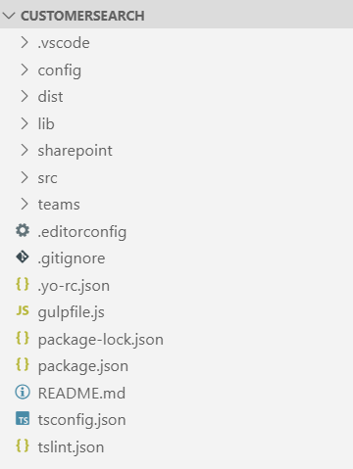

* 1. Inside the config folder, locate and open the configuration file named **package-solution.json**.
  2. Review the child properties of the **solution** property in **package-solution.json**. There is no need to make any edits to this file.

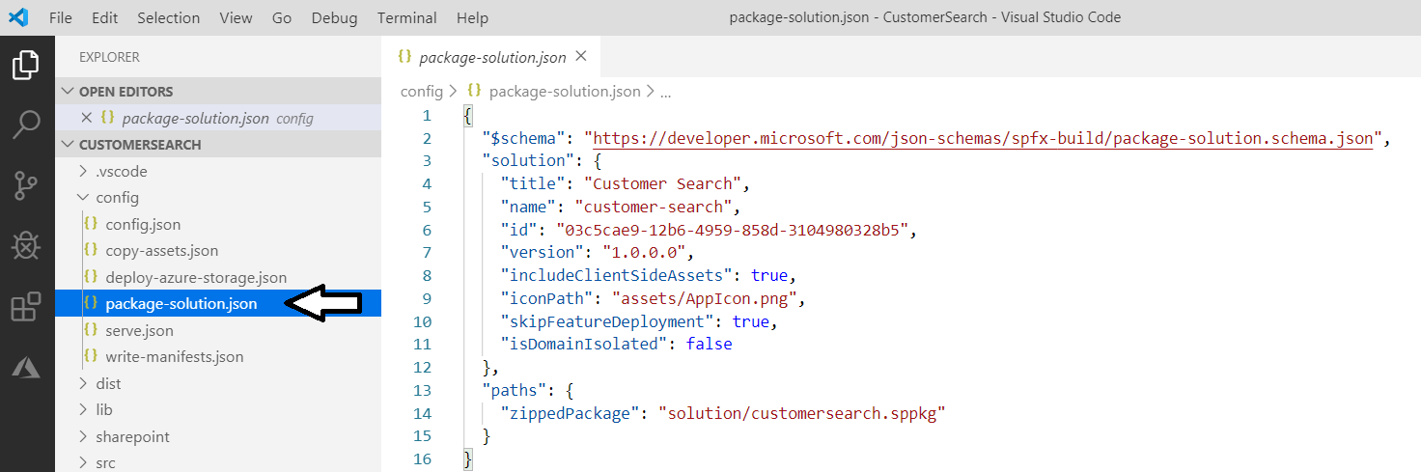

Note that he **skipFeatureDeployment** property is set to **true**. This makes it possible to deploy the webpart to every site collection at once without having to install the solution on a site collection by site collection basis.

1. Run npm install to restore the require npm packages to the project.
   1. Use the **View > Terminal** menu command to display the Integrated Terminal.
   2. Locate the console of the **Terminal** where you can type in and execute **npm** commands.
   3. Run the npm install command.

npm install

Once you have restored the npm packages, you can now build the solution into a distribution package.

1. Build the solution into a package for distribution.
   1. From the Terminal console, execute the gulp build command.

gulp build

* 1. When you execute the **gulp build** command, you will notice that it adds a new folder to the project named **lib**.

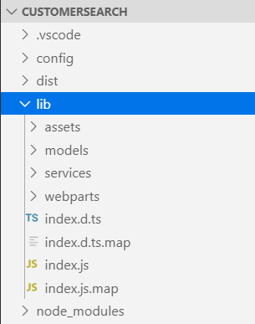

* 1. Bundle the solution by executing the following on the command line:

gulp bundle --ship

* 1. When you execute the **gulp bundle** command, you will notice that it adds a new folder to the project named **dist**.

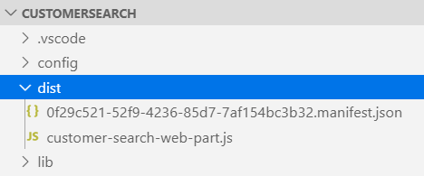

* 1. Package the solution by executing the following on the command line:

gulp package-solution --ship

* 1. When you execute the **gulp package-solution**, the command generates a solution package named **customer-search.sppkg** in the **sharepoint/solution/debug** folder.

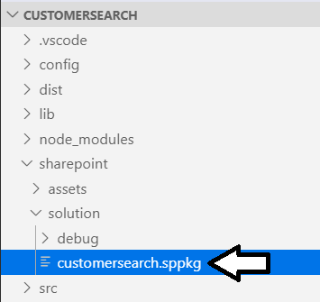

Now you have created the solution package you need to publish to the app catalog.

1. Deploy and trust the SharePoint package:
   1. In the browser, navigate to your SharePoint Online App Catalog.
   2. Select the **Apps for SharePoint** link in the navigation:

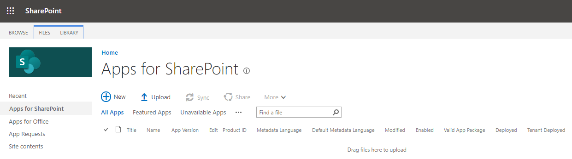

* 1. Drag the package from **\sharepoint\solution\customer-search.sppkg** into the **Apps for SharePoint** library.
  2. In the **Do you trust customer-search.sppkg?** dialog, select **Deploy**.

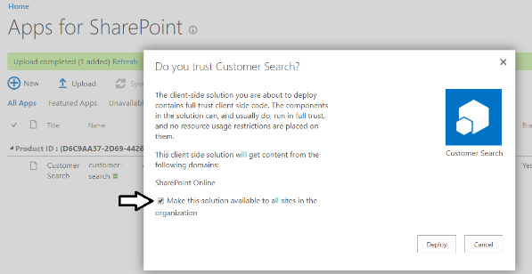

* 1. After a few seconds, you should see that solution package has been installed.

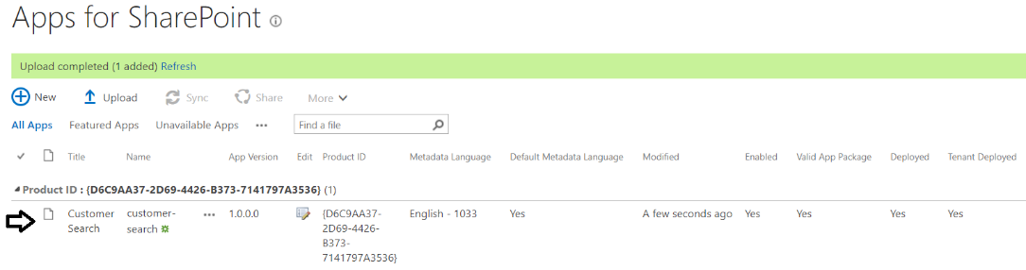

1. Add a Customer Search webpart to a modern page.
   1. In the browser, navigate to the SharePoint Communications site at the root of your tenant.

https://[YOUR_TENANT].sharepoint.com

* 1. Drop down the **Site Actions** menu and select the **Add a page** command.

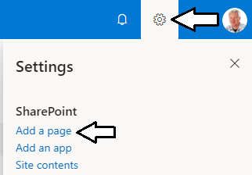

* 1. On the new modern page, enter a title of Test Page and click the X to remove the banner background image.

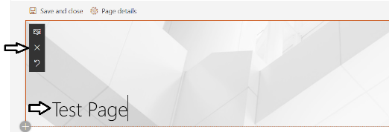

* 1. Click the + sign button to add a webpart.

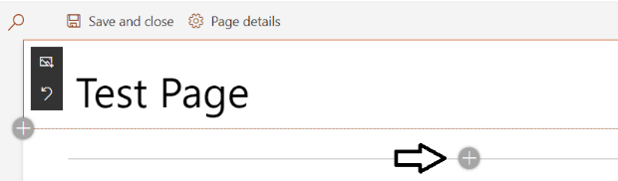

* 1. Locate the **Customer Search** webpart and add it to the page.

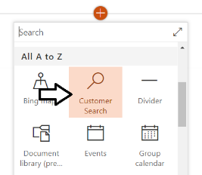

* 1. The webpart should appear and be functional on the page

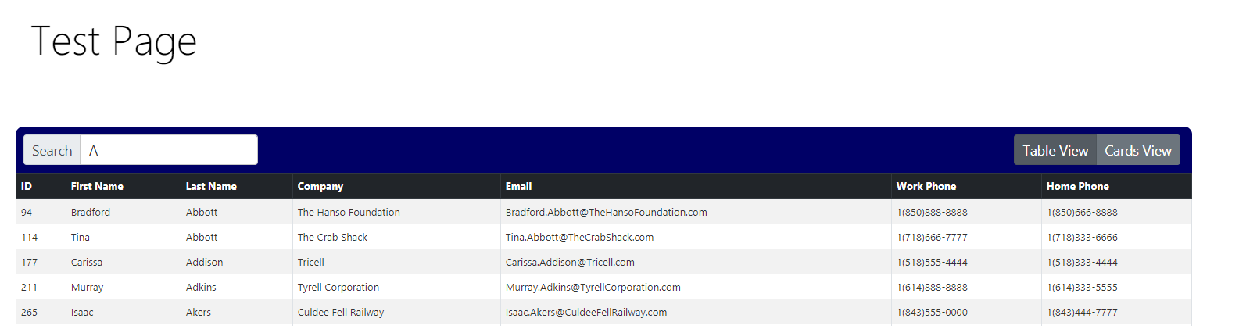

* 1. Save the modern page so you can return later and see this page with the Customer Search webpart.

### Exercise 3: Build and Deploy a Solution Package with an Application Customizer

In this exercise you will go through the steps to build a solution package with an application customizer for distribution.

1. Open the SharePoint Framework project named **GlobalNavigation**.
   1. Using Windows Explorer, navigate to the lab folder for this module at the following path.

C:\Student\Modules\06_PackagingAndDeployment\Lab

* 1. You should see two folders with SharePoint Framework projects named **CustomerSearch** and **GlobalNavigation**.



* 1. Open the folder named **GlobalNavigation** with Visual Studio Code.
  2. Take a moment to inspect the files and folder inside the project.

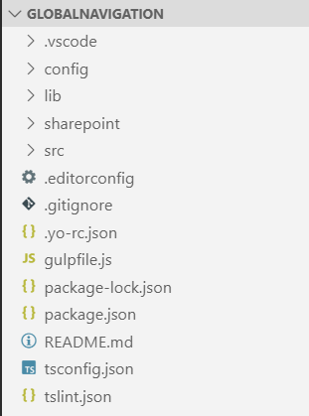

* 1. Inside the config folder, locate and open the configuration file named **package-solution.json**.
  2. Review the child properties of the **solution** property in **package-solution.json**. There is no need to make any edits to this file.

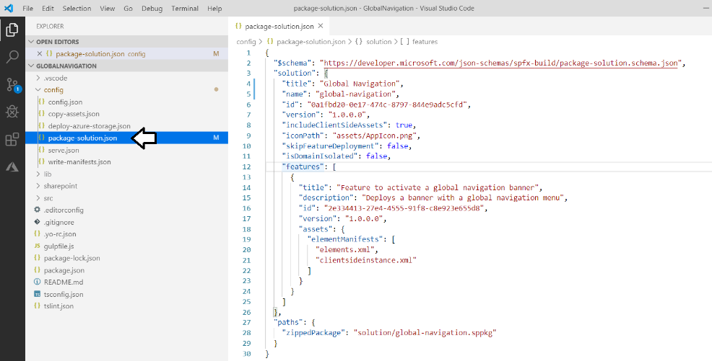

Note the **skipFeatureDeployment** property is false. That means this solution must be installed individually for each site collection.

1. Run npm install to restore the require npm packages to the project.
   1. Use the **View > Integrated Terminal** menu command to display the Integrated Terminal.
   2. Locate the console of the **Integrated Terminal** where you can type in and execute **npm** commands.
   3. Run the npm install command.

npm install

Once you have restored the npm packages, you can now build the solution into a distribution package.

1. Build the solution into a package for distribution.
   1. From the Terminal console, execute the gulp build command.

gulp build

* 1. When you execute the **gulp build** command, you will notice that it adds a new folder to the project named **lib**.
  2. Bundle the solution by executing the following on the command line:

gulp bundle --ship

* 1. When you execute the **gulp bundle** command, you will notice that it adds a new folder to the project named **dist**.
  2. Package the solution by executing the following on the command line:

gulp package-solution --ship

* 1. When you execute the **gulp package-solution**, the command generates a solution package named **global-navigation.sppkg** in the **sharepoint/solution/debug** folder.

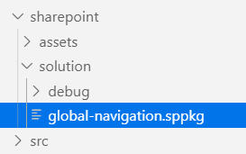

Now you have created the solution package you need to publish to the app catalog.

1. Deploy and trust the SharePoint package:
   1. In the browser, navigate to your SharePoint Online App Catalog.
   2. Select the **Apps for SharePoint** link in the navigation:
   3. Drag the package from **\sharepoint\solution\global-navigation.sppkg** into the **Apps for SharePoint** library.
   4. In the **Do you trust global-navigation?** dialog, select **Deploy**.

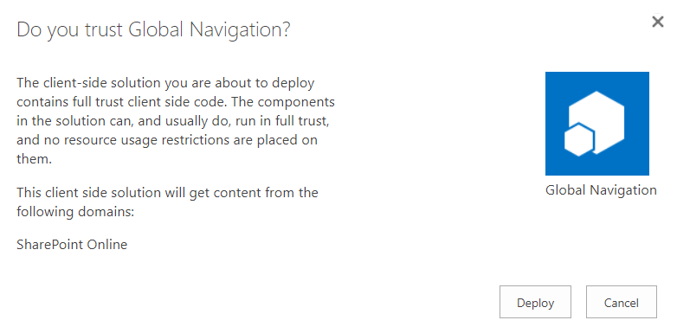

* 1. You should be able to verify that the solution package has been installed.

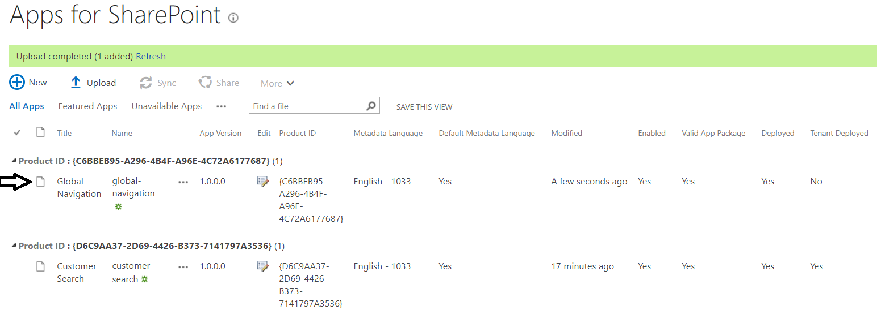

1. Install the **global-navigation** solution in a SharePoint site.
   1. In the browser, navigate to the SharePoint Communications site at the root of your tenant.

https://[YOUR_TENANT].sharepoint.com

* 1. From the **Site Actions** menu, select **Add an app** to install a new solution into the current site collection.

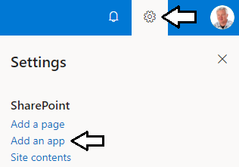

* 1. Locate and click on the solution package named Global Navigation to begin the installation process.

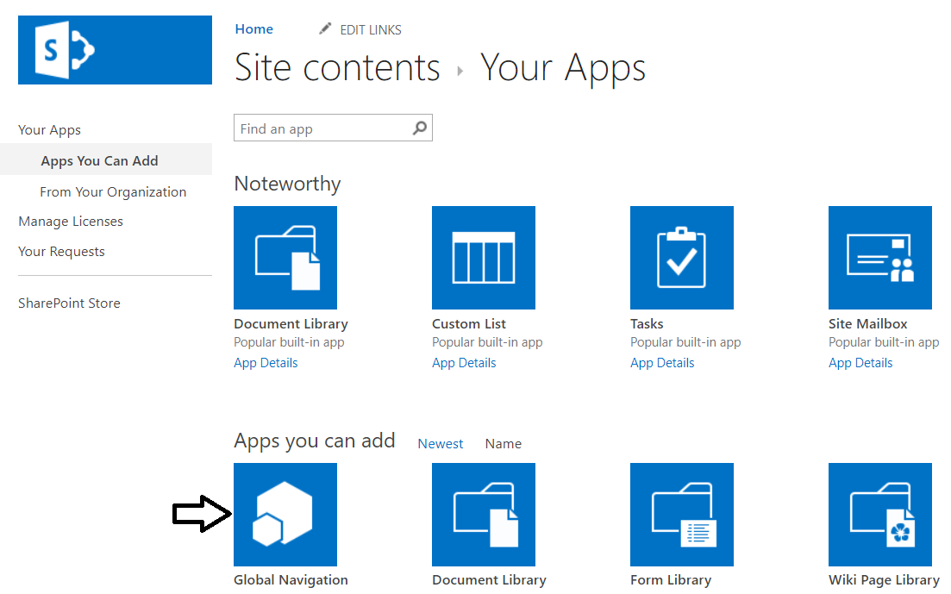

* 1. On the **Site Contents** page, you should see the new solution package appear in a greyed out state while it is installing.

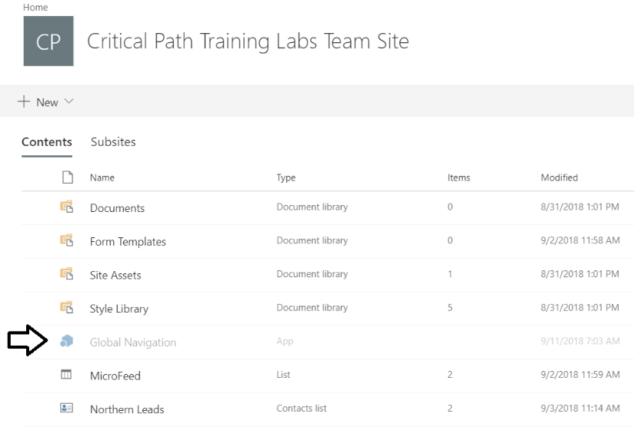

* 1. One the installation is done, refresh the page every 30 seconds until you should see the icon for the solution package enabled.
  2. You should also see that a global navigation menu added by an application customer appears at the top of the page.

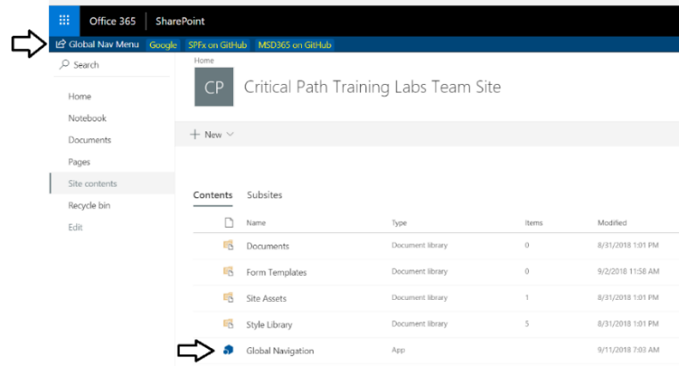

* 1. Navigate to the default view for the **Pages** document library. Due to the fact that the default view of the Pages library is a modern page, you should see that the global navigation continues to be displayed on this page as well.

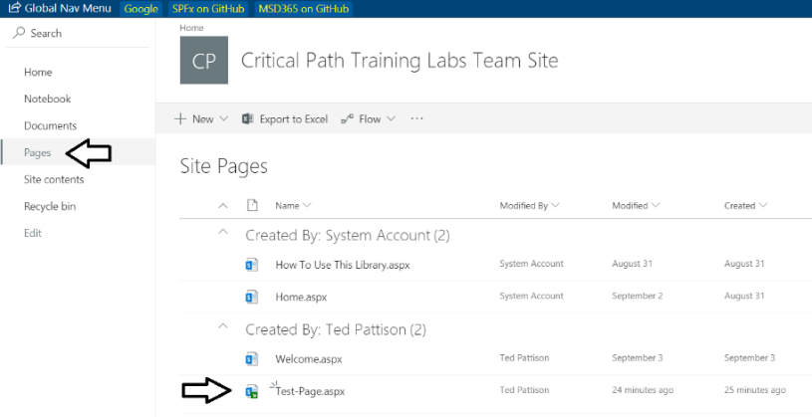

Now you will go to the site page you create in the previous exercise to see the application customer from the Global Navigation solution page appear on the same page as the Customer Search webpart created from the customer-search solution package.

* 1. Navigate to the test site page you created earlier when testing the webpart in exercise 2.
  2. You should see both the webpart and the application customizer appear on the same page.

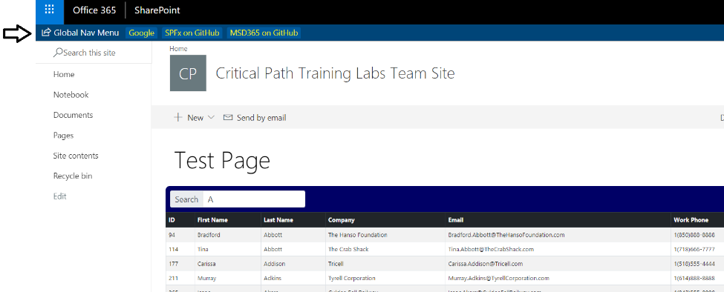

If you navigate to a classic page, you will not see the application customizer. Application customizers only appear on modern pages.